**1.Find all the information about each products**

**admin> db.product.json.find()**

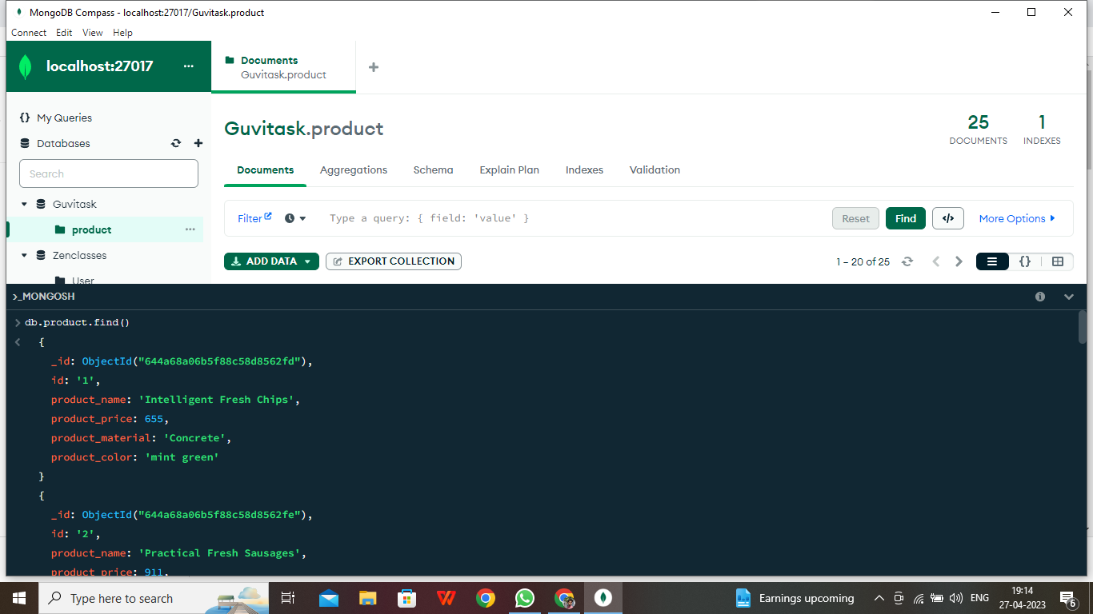

**[**

**{**

**_id: ObjectId("6479634f069299f913b2959b"),**

**id: '1',**

**product_name: 'Intelligent Fresh Chips',**

**product_price: 655,**

**product_material: 'Concrete',**

**product_color: 'mint green'**

**},**

**{**

**_id: ObjectId("6479634f069299f913b2959c"),**

**id: '2',**

**product_name: 'Practical Fresh Sausages',**

**product_price: 911,**

**product_material: 'Cotton',**

**product_color: 'indigo'**

**},**

**{**

**_id: ObjectId("6479634f069299f913b2959d"),**

**id: '3',**

**product_name: 'Refined Steel Car',**

**product_price: 690,**

**product_material: 'Rubber',**

**product_color: 'gold'**

**},**

**{**

**_id: ObjectId("6479634f069299f913b2959e"),**

**id: '4',**

**product_name: 'Gorgeous Plastic Pants',**

**product_price: 492,**

**product_material: 'Soft',**

**product_color: 'plum'**

**},**

**{**

**_id: ObjectId("6479634f069299f913b2959f"),**

**id: '5',**

**product_name: 'Sleek Cotton Chair',**

**product_price: 33,**

**product_material: 'Fresh',**

**product_color: 'black'**

**},**

**{**

**_id: ObjectId("6479634f069299f913b295a0"),**

**id: '6',**

**product_name: 'Awesome Wooden Towels',**

**product_price: 474,**

**product_material: 'Plastic',**

**product_color: 'orange'**

**},**

**{**

**_id: ObjectId("6479634f069299f913b295a1"),**

**id: '7',**

**product_name: 'Practical Soft Shoes',**

**product_price: 500,**

**product_material: 'Rubber',**

**product_color: 'pink'**

**},**

**{**

**_id: ObjectId("6479634f069299f913b295a2"),**

**id: '8',**

**product_name: 'Incredible Steel Hat',**

**product_price: 78,**

**product_material: 'Rubber',**

**product_color: 'violet'**

**},**

**{**

**_id: ObjectId("6479634f069299f913b295a3"),**

**id: '9',**

**product_name: 'Awesome Wooden Ball',**

**product_price: 28,**

**product_material: 'Soft',**

**product_color: 'azure'**

**},**

**{**

**_id: ObjectId("6479634f069299f913b295a4"),**

**id: '10',**

**product_name: 'Generic Wooden Pizza',**

**product_price: 84,**

**product_material: 'Frozen',**

**product_color: 'indigo'**

**},**

**{**

**_id: ObjectId("6479634f069299f913b295a5"),**

**id: '11',**

**product_name: 'Unbranded Wooden Cheese',**

**product_price: 26,**

**product_material: 'Soft',**

**product_color: 'black'**

**},**

**{**

**_id: ObjectId("6479634f069299f913b295a6"),**

**id: '12',**

**product_name: 'Unbranded Plastic Salad',**

**product_price: 89,**

**product_material: 'Wooden',**

**product_color: 'pink'**

**},**

**{**

**_id: ObjectId("6479634f069299f913b295a7"),**

**id: '13',**

**product_name: 'Gorgeous Cotton Keyboard',**

**product_price: 37,**

**product_material: 'Concrete',**

**product_color: 'sky blue'**

**},**

**{**

**_id: ObjectId("6479634f069299f913b295a8"),**

**id: '14',**

**product_name: 'Incredible Steel Shirt',**

**product_price: 54,**

**product_material: 'Metal',**

**product_color: 'white'**

**},**

**{**

**_id: ObjectId("6479634f069299f913b295a9"),**

**id: '15',**

**product_name: 'Ergonomic Cotton Hat',**

**product_price: 43,**

**product_material: 'Rubber',**

**product_color: 'mint green'**

**},**

**{**

**_id: ObjectId("6479634f069299f913b295aa"),**

**id: '16',**

**product_name: 'Small Soft Chair',**

**product_price: 47,**

**product_material: 'Cotton',**

**product_color: 'teal'**

**},**

**{**

**_id: ObjectId("6479634f069299f913b295ab"),**

**id: '17',**

**product_name: 'Incredible Metal Car',**

**product_price: 36,**

**product_material: 'Fresh',**

**product_color: 'indigo'**

**},**

**{**

**_id: ObjectId("6479634f069299f913b295ac"),**

**id: '18',**

**product_name: 'Licensed Plastic Bacon',**

**product_price: 88,**

**product_material: 'Steel',**

**product_color: 'yellow'**

**},**

**{**

**_id: ObjectId("6479634f069299f913b295ad"),**

**id: '19',**

**product_name: 'Intelligent Cotton Chips',**

**product_price: 46,**

**product_material: 'Soft',**

**product_color: 'azure'**

**},**

**{**

**_id: ObjectId("6479634f069299f913b295ae"),**

**id: '20',**

**product_name: 'Handcrafted Wooden Bacon',**

**product_price: 36,**

**product_material: 'Concrete',**

**product_color: 'lime'**

**}**

**]**

**Type "it" for more**

**admin> it**

**[**

**{**

**_id: ObjectId("6479634f069299f913b295af"),**

**id: '21',**

**product_name: 'Unbranded Granite Chicken',**

**product_price: 90,**

**product_material: 'Metal',**

**product_color: 'gold'**

**},**

**{**

**_id: ObjectId("6479634f069299f913b295b0"),**

**id: '22',**

**product_name: 'Ergonomic Soft Hat',**

**product_price: 99,**

**product_material: 'Rubber',**

**product_color: 'black'**

**},**

**{**

**_id: ObjectId("6479634f069299f913b295b1"),**

**id: '23',**

**product_name: 'Intelligent Steel Pizza',**

**product_price: 95,**

**product_material: 'Cotton',**

**product_color: 'azure'**

**},**

**{**

**_id: ObjectId("6479634f069299f913b295b2"),**

**id: '24',**

**product_name: 'Tasty Rubber Cheese',**

**product_price: 47,**

**product_material: 'Frozen',**

**product_color: 'orchid'**

**},**

**{**

**_id: ObjectId("6479634f069299f913b295b3"),**

**id: '25',**

**product_name: 'Licensed Steel Car',**

**product_price: 20,**

**product_material: 'Cotton',**

**product_color: 'indigo'**

**}**

**]**

**2.Find the product price which are between 400 to 800**

**admin> db.product.json.find({product_price:{"$gte":400,"$lte":800}})**

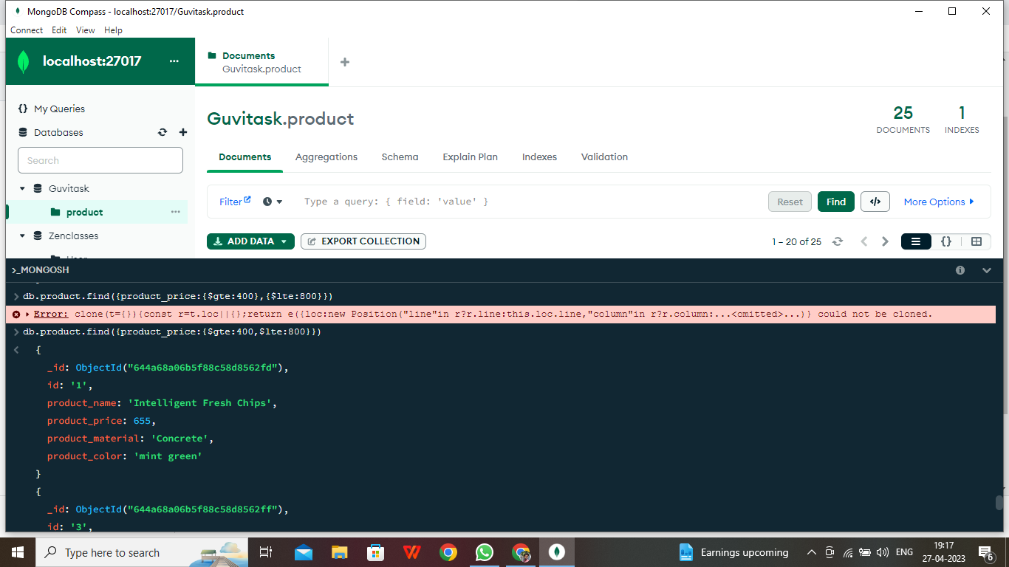

**[**

**{**

**_id: ObjectId("6479634f069299f913b2959b"),**

**id: '1',**

**product_name: 'Intelligent Fresh Chips',**

**product_price: 655,**

**product_material: 'Concrete',**

**product_color: 'mint green'**

**},**

**{**

**_id: ObjectId("6479634f069299f913b2959d"),**

**id: '3',**

**product_name: 'Refined Steel Car',**

**product_price: 690,**

**product_material: 'Rubber',**

**product_color: 'gold'**

**},**

**{**

**_id: ObjectId("6479634f069299f913b2959e"),**

**id: '4',**

**product_name: 'Gorgeous Plastic Pants',**

**product_price: 492,**

**product_material: 'Soft',**

**product_color: 'plum'**

**},**

**{**

**_id: ObjectId("6479634f069299f913b295a0"),**

**id: '6',**

**product_name: 'Awesome Wooden Towels',**

**product_price: 474,**

**product_material: 'Plastic',**

**product_color: 'orange'**

**},**

**{**

**_id: ObjectId("6479634f069299f913b295a1"),**

**id: '7',**

**product_name: 'Practical Soft Shoes',**

**product_price: 500,**

**product_material: 'Rubber',**

**product_color: 'pink'**

**]**

**3.Find the product price which are not between 400 to 600**

**admin> db.product.json.find({product_price:{"$not":{"$gte":400,"$lte":600}}})**

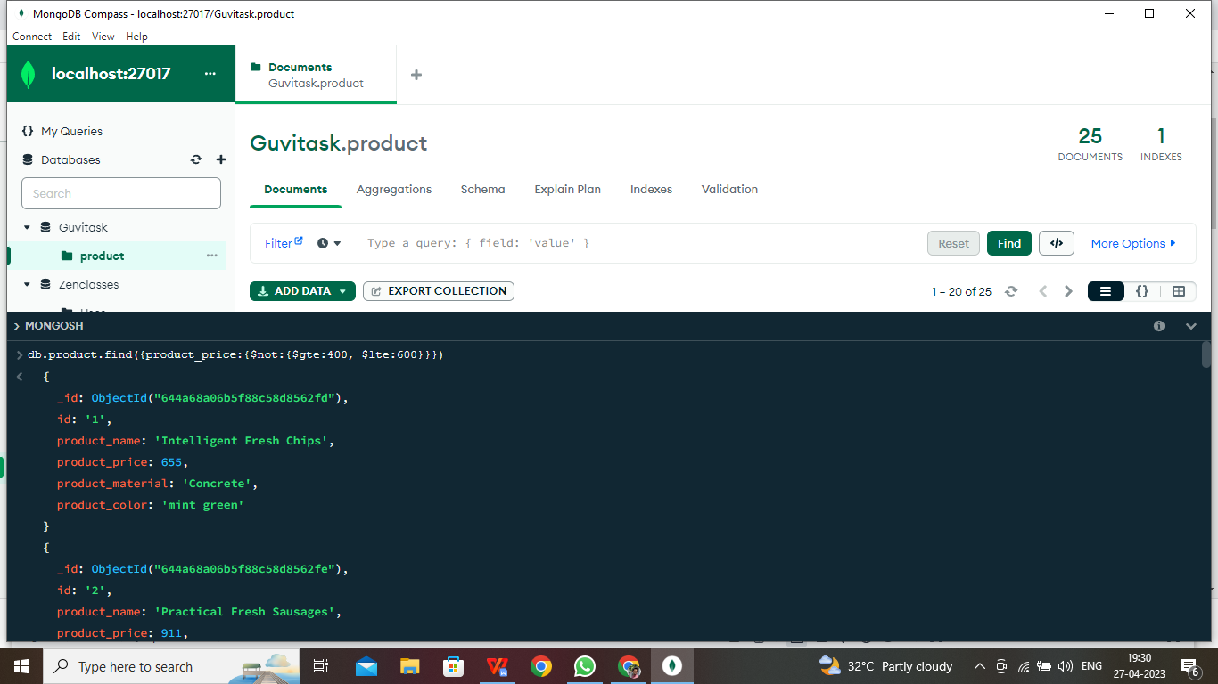

**[**

**{**

**_id: ObjectId("6479634f069299f913b2959b"),**

**id: '1',**

**product_name: 'Intelligent Fresh Chips',**

**product_price: 655,**

**product_material: 'Concrete',**

**product_color: 'mint green'**

**},**

**{**

**_id: ObjectId("6479634f069299f913b2959c"),**

**id: '2',**

**product_name: 'Practical Fresh Sausages',**

**product_price: 911,**

**product_material: 'Cotton',**

**product_color: 'indigo'**

**},**

**{**

**_id: ObjectId("6479634f069299f913b2959d"),**

**id: '3',**

**product_name: 'Refined Steel Car',**

**product_price: 690,**

**product_material: 'Rubber',**

**product_color: 'gold'**

**},**

**{**

**_id: ObjectId("6479634f069299f913b2959f"),**

**id: '5',**

**product_name: 'Sleek Cotton Chair',**

**product_price: 33,**

**product_material: 'Fresh',**

**product_color: 'black'**

**},**

**{**

**_id: ObjectId("6479634f069299f913b295a2"),**

**id: '8',**

**product_name: 'Incredible Steel Hat',**

**product_price: 78,**

**product_material: 'Rubber',**

**product_color: 'violet'**

**},**

**{**

**_id: ObjectId("6479634f069299f913b295a3"),**

**id: '9',**

**product_name: 'Awesome Wooden Ball',**

**product_price: 28,**

**product_material: 'Soft',**

**product_color: 'azure'**

**},**

**{**

**_id: ObjectId("6479634f069299f913b295a4"),**

**id: '10',**

**product_name: 'Generic Wooden Pizza',**

**product_price: 84,**

**product_material: 'Frozen',**

**product_color: 'indigo'**

**},**

**{**

**_id: ObjectId("6479634f069299f913b295a5"),**

**id: '11',**

**product_name: 'Unbranded Wooden Cheese',**

**product_price: 26,**

**product_material: 'Soft',**

**product_color: 'black'**

**},**

**{**

**_id: ObjectId("6479634f069299f913b295a6"),**

**id: '12',**

**product_name: 'Unbranded Plastic Salad',**

**product_price: 89,**

**product_material: 'Wooden',**

**product_color: 'pink'**

**},**

**{**

**_id: ObjectId("6479634f069299f913b295a7"),**

**id: '13',**

**product_name: 'Gorgeous Cotton Keyboard',**

**product_price: 37,**

**product_material: 'Concrete',**

**product_color: 'sky blue'**

**},**

**{**

**_id: ObjectId("6479634f069299f913b295a8"),**

**id: '14',**

**product_name: 'Incredible Steel Shirt',**

**product_price: 54,**

**product_material: 'Metal',**

**product_color: 'white'**

**},**

**{**

**_id: ObjectId("6479634f069299f913b295a9"),**

**id: '15',**

**product_name: 'Ergonomic Cotton Hat',**

**product_price: 43,**

**product_material: 'Rubber',**

**product_color: 'mint green'**

**},**

**{**

**_id: ObjectId("6479634f069299f913b295aa"),**

**id: '16',**

**product_name: 'Small Soft Chair',**

**product_price: 47,**

**product_material: 'Cotton',**

**product_color: 'teal'**

**},**

**{**

**_id: ObjectId("6479634f069299f913b295ab"),**

**id: '17',**

**product_name: 'Incredible Metal Car',**

**product_price: 36,**

**product_material: 'Fresh',**

**product_color: 'indigo'**

**},**

**{**

**_id: ObjectId("6479634f069299f913b295ac"),**

**id: '18',**

**product_name: 'Licensed Plastic Bacon',**

**product_price: 88,**

**product_material: 'Steel',**

**product_color: 'yellow'**

**},**

**{**

**_id: ObjectId("6479634f069299f913b295ad"),**

**id: '19',**

**product_name: 'Intelligent Cotton Chips',**

**product_price: 46,**

**product_material: 'Soft',**

**product_color: 'azure'**

**},**

**{**

**_id: ObjectId("6479634f069299f913b295ae"),**

**id: '20',**

**product_name: 'Handcrafted Wooden Bacon',**

**product_price: 36,**

**product_material: 'Concrete',**

**product_color: 'lime'**

**},**

**{**

**_id: ObjectId("6479634f069299f913b295af"),**

**id: '21',**

**product_name: 'Unbranded Granite Chicken',**

**product_price: 90,**

**product_material: 'Metal',**

**product_color: 'gold'**

**},**

**{**

**_id: ObjectId("6479634f069299f913b295b0"),**

**id: '22',**

**product_name: 'Ergonomic Soft Hat',**

**product_price: 99,**

**product_material: 'Rubber',**

**product_color: 'black'**

**},**

**{**

**_id: ObjectId("6479634f069299f913b295b1"),**

**id: '23',**

**product_name: 'Intelligent Steel Pizza',**

**product_price: 95,**

**product_material: 'Cotton',**

**product_color: 'azure'**

**}**

**]**

**4.List the four product which are grater than 500 in price**

**admin> db.product.json.find({product_price:{$gte:500}}).limit(4)**

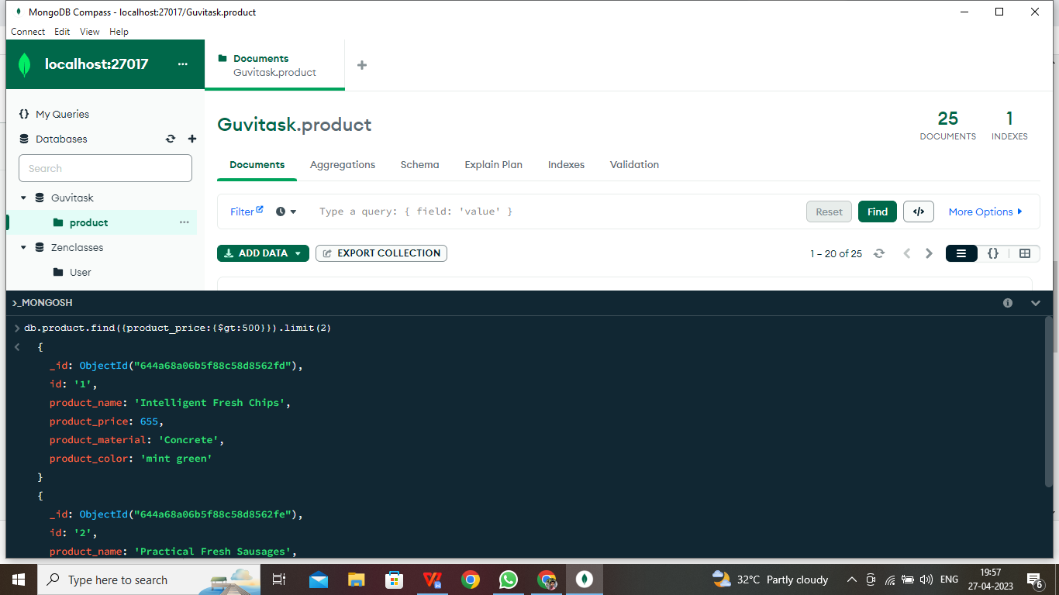

**[**

**{**

**_id: ObjectId("6479634f069299f913b2959b"),**

**id: '1',**

**product_name: 'Intelligent Fresh Chips',**

**product_price: 655,**

**product_material: 'Concrete',**

**product_color: 'mint green'**

**},**

**{**

**_id: ObjectId("6479634f069299f913b2959c"),**

**id: '2',**

**product_name: 'Practical Fresh Sausages',**

**product_price: 911,**

**product_material: 'Cotton',**

**product_color: 'indigo'**

**},**

**{**

**_id: ObjectId("6479634f069299f913b2959d"),**

**id: '3',**

**product_name: 'Refined Steel Car',**

**product_price: 690,**

**product_material: 'Rubber',**

**product_color: 'gold'**

**},**

**{**

**_id: ObjectId("6479634f069299f913b295a1"),**

**id: '7',**

**product_name: 'Practical Soft Shoes',**

**product_price: 500,**

**product_material: 'Rubber',**

**product_color: 'pink'**

**}**

**]**

**5.Find the product name and product material of each products**

**admin> db.product.json.find({product_price:{$gte:0}},{product_price:1,productproduct_name:1,_id:0})**

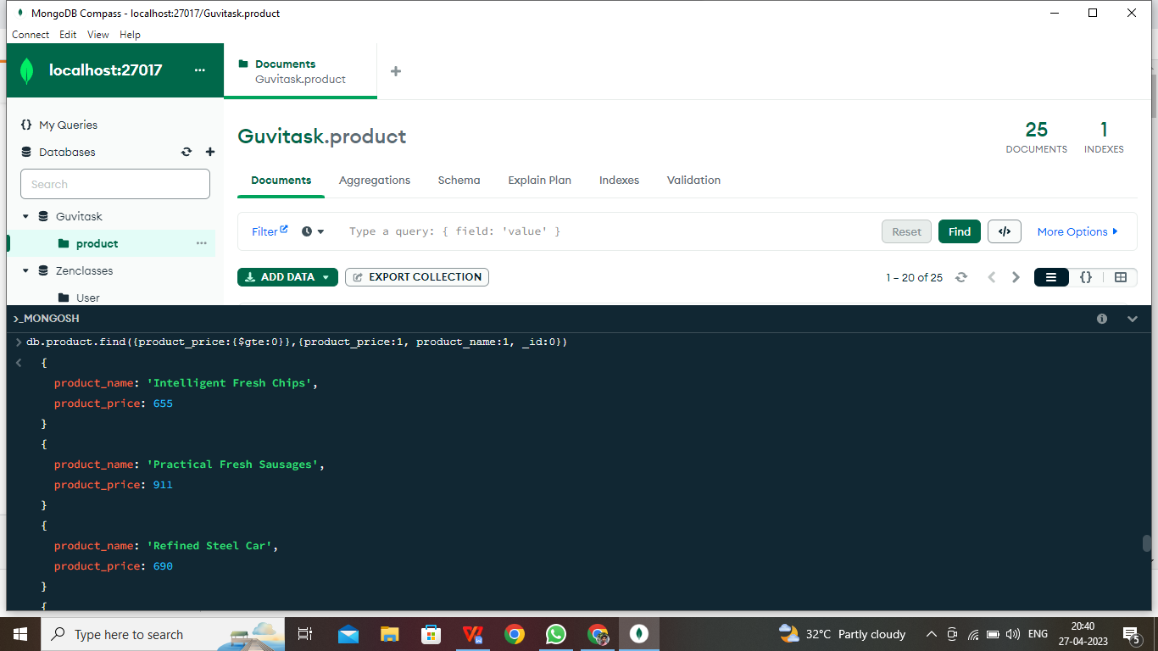

**[**

**{ product_name: 'Intelligent Fresh Chips', product_price: 655 },**

**{ product_name: 'Practical Fresh Sausages', product_price: 911 },**

**{ product_name: 'Refined Steel Car', product_price: 690 },**

**{ product_name: 'Gorgeous Plastic Pants', product_price: 492 },**

**{ product_name: 'Sleek Cotton Chair', product_price: 33 },**

**{ product_name: 'Awesome Wooden Towels', product_price: 474 },**

**{ product_name: 'Practical Soft Shoes', product_price: 500 },**

**{ product_name: 'Incredible Steel Hat', product_price: 78 },**

**{ product_name: 'Awesome Wooden Ball', product_price: 28 },**

**{ product_name: 'Generic Wooden Pizza', product_price: 84 },**

**{ product_name: 'Unbranded Wooden Cheese', product_price: 26 },**

**{ product_name: 'Unbranded Plastic Salad', product_price: 89 },**

**{ product_name: 'Gorgeous Cotton Keyboard', product_price: 37 },**

**{ product_name: 'Incredible Steel Shirt', product_price: 54 },**

**{ product_name: 'Ergonomic Cotton Hat', product_price: 43 },**

**{ product_name: 'Small Soft Chair', product_price: 47 },**

**{ product_name: 'Incredible Metal Car', product_price: 36 },**

**{ product_name: 'Licensed Plastic Bacon', product_price: 88 },**

**{ product_name: 'Intelligent Cotton Chips', product_price: 46 },**

**{ product_name: 'Handcrafted Wooden Bacon', product_price: 36 }**

**]**

**Type "it" for more**

**admin> it**

**[**

**{ product_name: 'Unbranded Granite Chicken', product_price: 90 },**

**{ product_name: 'Ergonomic Soft Hat', product_price: 99 },**

**{ product_name: 'Intelligent Steel Pizza', product_price: 95 },**

**{ product_name: 'Tasty Rubber Cheese', product_price: 47 },**

**{ product_name: 'Licensed Steel Car', product_price: 20 }**

**]**

**6.Find the product with a row id of 10**

**admin> db.product.json.find({id:'10'})**

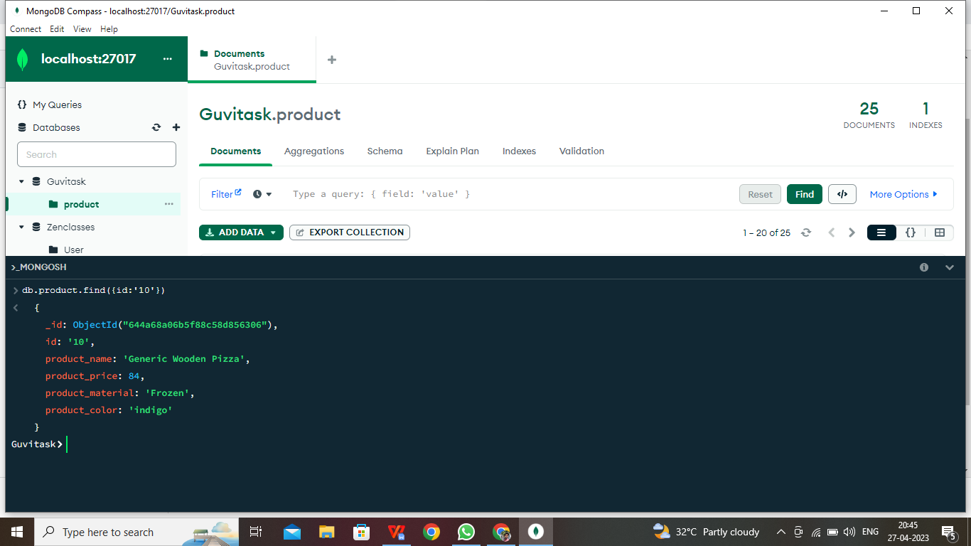

**[**

**{**

**_id: ObjectId("6479634f069299f913b295a4"),**

**id: '10',**

**product_name: 'Generic Wooden Pizza',**

**product_price: 84,**

**product_material: 'Frozen',**

**product_color: 'indigo'**

**}**

**]**

**7.Find only the product name and product material**

**admin> db.product.json.find({product_price:{$gte:0}},{product_material:1,product_name:1,_id:0})**

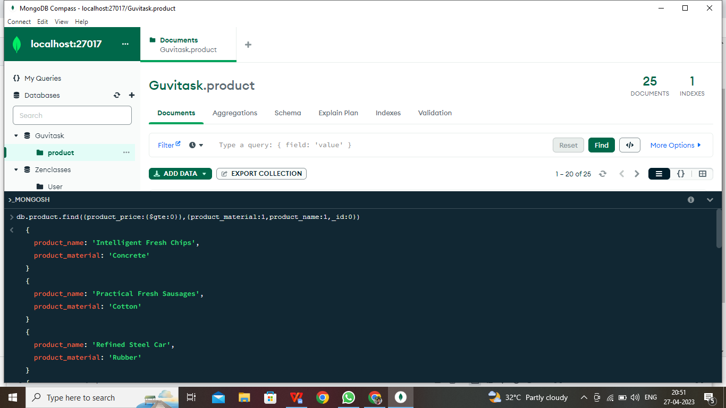

**[**

**{**

**product_name: 'Intelligent Fresh Chips',**

**product_material: 'Concrete'**

**},**

**{**

**product_name: 'Practical Fresh Sausages',**

**product_material: 'Cotton'**

**},**

**{ product_name: 'Refined Steel Car', product_material: 'Rubber' }, { product_name: 'Gorgeous Plastic Pants', product_material: 'Soft' },**

**{ product_name: 'Sleek Cotton Chair', product_material: 'Fresh' }, {**

**product_name: 'Awesome Wooden Towels',**

**product_material: 'Plastic'**

**},**

**{ product_name: 'Practical Soft Shoes', product_material: 'Rubber' },**

**{ product_name: 'Incredible Steel Hat', product_material: 'Rubber' },**

**{ product_name: 'Awesome Wooden Ball', product_material: 'Soft' }, { product_name: 'Generic Wooden Pizza', product_material: 'Frozen' },**

**{ product_name: 'Unbranded Wooden Cheese', product_material: 'Soft' },**

**{**

**product_name: 'Unbranded Plastic Salad',**

**product_material: 'Wooden'**

**},**

**{**

**product_name: 'Gorgeous Cotton Keyboard',**

**product_material: 'Concrete'**

**},**

**{ product_name: 'Incredible Steel Shirt', product_material: 'Metal' },**

**{ product_name: 'Ergonomic Cotton Hat', product_material: 'Rubber' },**

**{ product_name: 'Small Soft Chair', product_material: 'Cotton' },**

**{ product_name: 'Incredible Metal Car', product_material: 'Fresh' },**

**{ product_name: 'Licensed Plastic Bacon', product_material: 'Steel' },**

**{**

**product_name: 'Intelligent Cotton Chips',**

**product_material: 'Soft'**

**},**

**{**

**product_name: 'Handcrafted Wooden Bacon',**

**product_material: 'Concrete'**

**}**

**]**

**Type "it" for more**

**admin> it**

**[**

**{**

**product_name: 'Unbranded Granite Chicken',**

**product_material: 'Metal'**

**},**

**{ product_name: 'Ergonomic Soft Hat', product_material: 'Rubber' },**

**{**

**product_name: 'Intelligent Steel Pizza',**

**product_material: 'Cotton'**

**},**

**{ product_name: 'Tasty Rubber Cheese', product_material: 'Frozen' },**

**{ product_name: 'Licensed Steel Car', product_material: 'Cotton' }]**

**8.Find all products which contain the value of soft in product material**

**admin> db.product.json.find({product_material:{$regex:'Soft'}})**

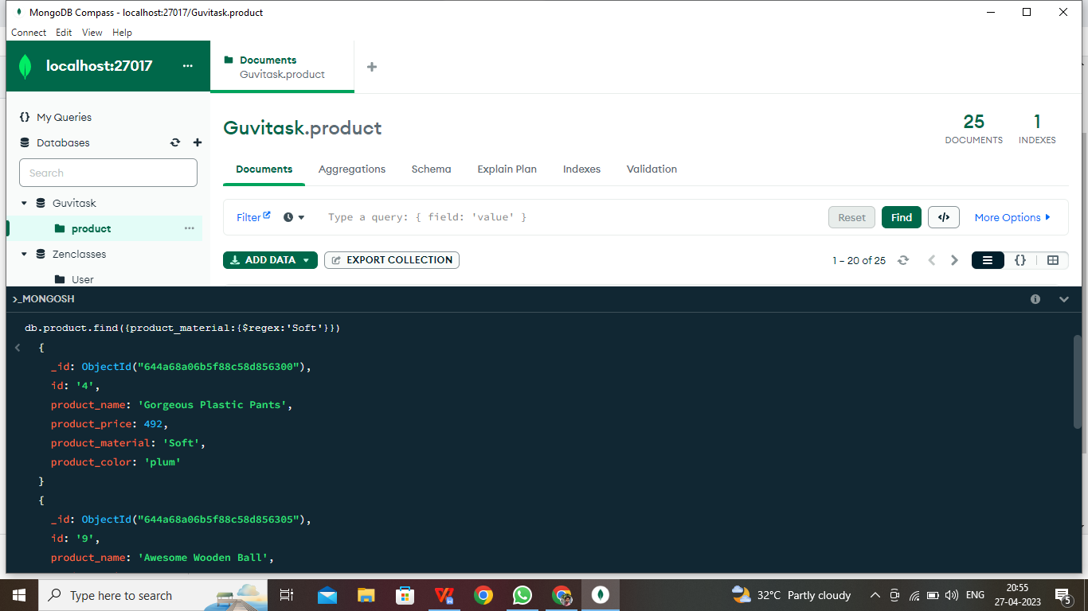

**[**

**{**

**_id: ObjectId("6479634f069299f913b2959e"),**

**id: '4',**

**product_name: 'Gorgeous Plastic Pants',**

**product_price: 492,**

**product_material: 'Soft',**

**product_color: 'plum'**

**},**

**{**

**_id: ObjectId("6479634f069299f913b295a3"),**

**id: '9',**

**product_name: 'Awesome Wooden Ball',**

**product_price: 28,**

**product_material: 'Soft',**

**product_color: 'azure'**

**},**

**{**

**_id: ObjectId("6479634f069299f913b295a5"),**

**id: '11',**

**product_name: 'Unbranded Wooden Cheese',**

**product_price: 26,**

**product_material: 'Soft',**

**product_color: 'black'**

**},**

**{**

**_id: ObjectId("6479634f069299f913b295ad"),**

**id: '19',**

**product_name: 'Intelligent Cotton Chips',**

**product_price: 46,**

**product_material: 'Soft',**

**product_color: 'azure'**

**}**

**]**

**9.Find products which contain product color indigo and product price 492.00**

**admin> db.getCollection('product.json').aggregate([{$match:{product_color:'indigo'}}])**

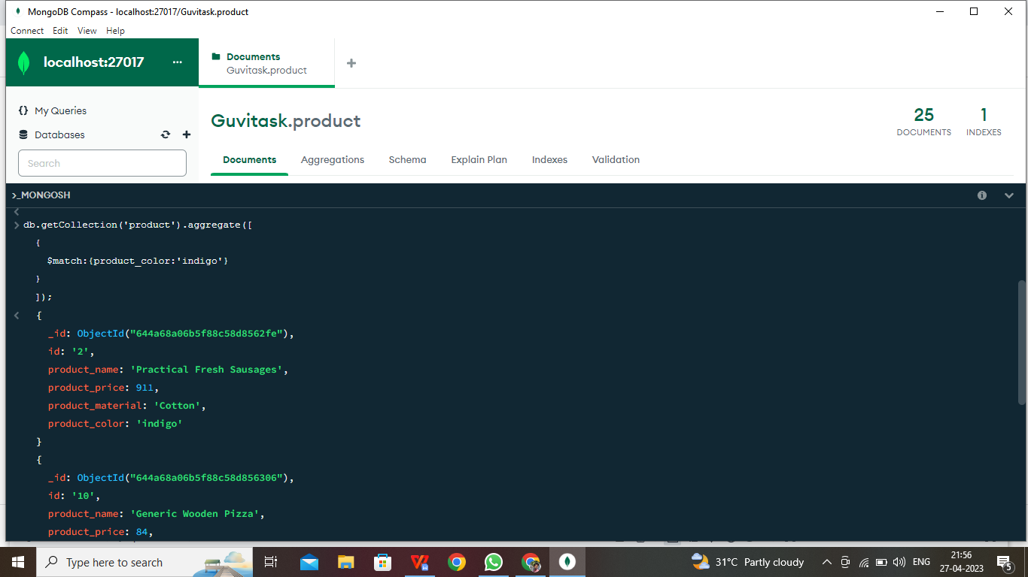

**[**

**{**

**_id: ObjectId("6479634f069299f913b2959c"),**

**id: '2',**

**product_name: 'Practical Fresh Sausages',**

**product_price: 911,**

**product_material: 'Cotton',**

**product_color: 'indigo'**

**},**

**{**

**_id: ObjectId("6479634f069299f913b295a4"),**

**id: '10',**

**product_name: 'Generic Wooden Pizza',**

**product_price: 84,**

**product_material: 'Frozen',**

**product_color: 'indigo'**

**},**

**{**

**_id: ObjectId("6479634f069299f913b295ab"),**

**id: '17',**

**product_name: 'Incredible Metal Car',**

**product_price: 36,**

**product_material: 'Fresh',**

**product_color: 'indigo'**

**},**

**{**

**_id: ObjectId("6479634f069299f913b295b3"),**

**id: '25',**

**product_name: 'Licensed Steel Car',**

**product_price: 20,**

**product_material: 'Cotton',**

**product_color: 'indigo'**

**}**

**]**

**10. Delete the products which product price value are same**

**admin> db.getCollection('product.json').aggregate([{$match:{product_product_price:492}}])**

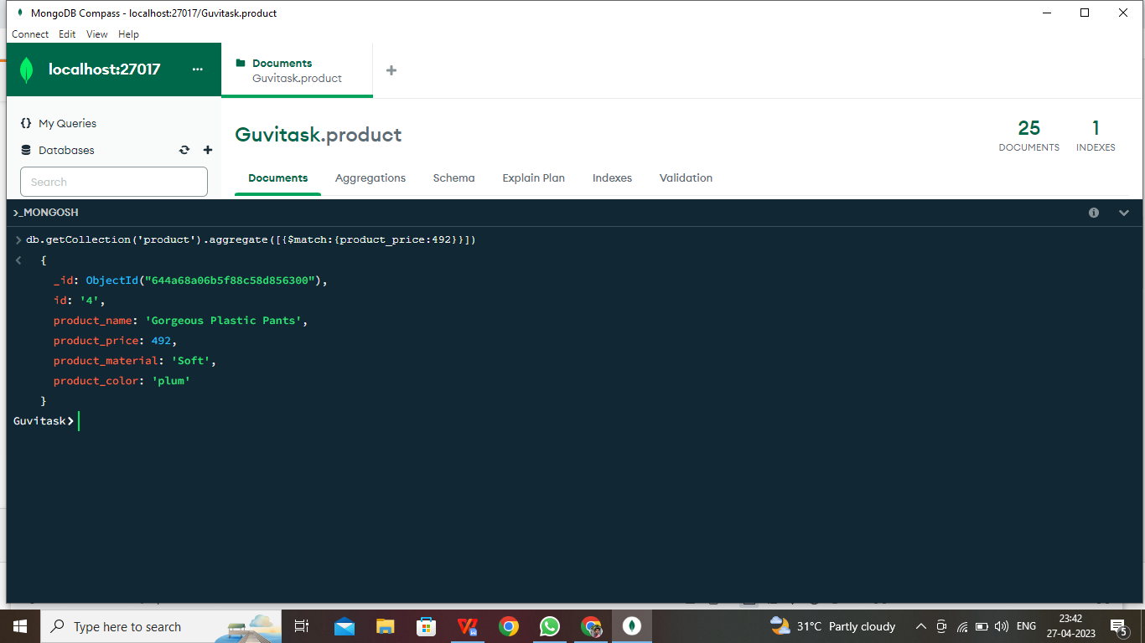

**[**

**{**

**_id: ObjectId("6479634f069299f913b2959e"),**

**id: '4',**

**product_name: 'Gorgeous Plastic Pants',**

**product_price: 492,**

**product_material: 'Soft',**

**product_color: 'plum'**

**}**

**]**